Lab1.htm; created August 11, 2010

**Bock Repair Parts Sales Lab 1**

Bock Repair Parts Sales LLC, specializes in the sale of repair parts for automobiles, trucks, and various commercial vehicles. During this term you will complete a series of programming assignments similar to those that you might perform while working as a computer programmer for this hypothetical firm.

**Getting Started.**

* Start Visual Studio.
* Click the Create Project hyperlink or use the File-New Project menu option.
* In the New Project dialog box type a name for the project—name the project **Lab1-SectionTime-YourLastName-YourFirstName** – for example, if your name is Doug Bock and you are in the 2:00 pm class section, name the project **Lab1-200-Bock-Doug**.
* Change the form’s **File Name** property from **Form1.vb** to a new name – **Lab1.vb**.
* Click the Save All button on the button toolbar. The Save Project dialog box will display. In the Location drop-down combo box save the project to your **My Documents** folder.
* Continue your work on the project. Periodically you should click the Save All button so you don’t lose any work.

**Design Requirements.** Develop a form that is similar to the one shown below. Your form may have minor differences. The form will enable the display of information about repair parts and services that the company has on sale.

* The form has a large label centered with bold and italic 16-point text that display the words “Bock Repair Parts Specials”.
* The form has two label controls (they display the words **Repair Part Description:** and **Price:).**
* Two TextBox controls are read-only to display output information about repair parts.
* Six button controls with capabilities as described below.
* A final label control that displays the programmer’s name – you must replace the name “Douglas Bock” with your own name.

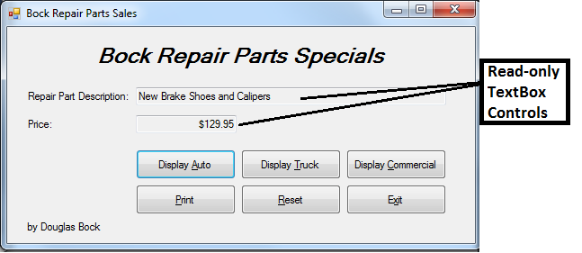

**Build and Code the Project.**

* The description and price of a repair part or service should display to the two TextBox controls with the **ReadOnly** property = **True** because the TextBox controls on this form are used for output, not input.
* Three Display Buttons: when a button is clicked, the relevant information should display on the form as shown in the figure – the figure shows information displayed when the Display Auto Button is clicked. The data to be displayed for each of these three buttons are given in the table shown below.

|  |  |  |
| --- | --- | --- |
| ***Test Data***   Button to be clicked | Repair Part Information | Price |
| Display Auto | New Brake Shoes and Calipers | $129.95 |
| Display Truck | Heavy Duty Tires on Sale | $185.50 |
| Display Commercial | Discounted Commercial Annual Inspections | $82.49 |

* Print Button: prints the form to the computer screen using print preview.
* Reset Button: resets the form for use by clearing the information displayed in the two output TextBox controls.
* Exit Button: closes the application.
* On startup, the form must display in the center of the computer screen and the textbox controls must be blank.
* When designing the form, select control names that follow the naming convention specified in the textbook and notes.
* Include remarks statements in your code (also called comments) (before the Public Class declaration) that include the PROJECT, PROGRAMMER NAME, and DATE. Example:

‘Project: Lab1

‘Programmer: D. Bock

‘Date: (type today’s date here).

* Include remarks statements inside of each sub procedure to identify what the sub procedure does at a minimum.

**Test the Lab.** Test your lab to ensure that it works correctly. Use the assessment grading form shown below—it is the same form that will be used to grade your project.

**CAUTION: DO NOT run your project from a flash drive – this can cause the project to become corrupted and you will have to recreate the project – always copy the project to the drive C:\TEMP folder or to My Documents and test run your project.**

**What to Do When You’re Finished, How to Save and Submit the Lab.**

Ok, you’ve finished the lab. **Do NOT use the File menu, Save As option**. Instead, follow these steps.

* First, CLOSE Visual Studio—you cannot copy the project to another location if it is open.
* Locate the folder that contains the project. It should be located in the **My Documents** folder where you first saved the project.
* Copy the entire folder to a flash drive.
* Bring the flash drive to the University to either a computer lab or to the computer classroom. Copy the entire folder to drive Y: to the submission folder for your class. You can copy the folder to drive Y: at the beginning of the class period when the project is due.

**Visual Basic Project Assessment Plan – Lab 1 (20 points possible).**

**Before startup.**

* Submitted late – see the course syllabus for a description of the late penalty.
* Submitted on time but some of the files necessary to run the project are missing – you must resubmit the project, see your instructor if you need assistance submitting the project – your resubmission will be considered a late submission.
* Project should be named correctly: **Lab1-SectionTime-YourLastName-YourFirstName**.
* Form’s File Name property is correct (should be Lab1.vb, NOT Form1.vb).
* Form’s Title bar displays correct information.
* Label controls have font settings (bold & italic and centered where appropriate according to the figure).
* Label with student name is correct.
* Form has a good appearance: controls aligned, control size appropriate, no misspelled words, not too much gray space around controls.
* Program code has the required remarks statements to identify the program, programmer name, and date programmed.
* Each sub procedure has remarks statements to identify what the sub procedure does.
* Textbox and Button controls are named properly following the naming convention taught in the notes and in class.
* Delete empty sub procedures that you created accidentally - these have have no executable code.

**Startup.**

* Attempted startup, but the program will not execute due to a compilation error (-8 points, continue to check the form design settings and program code visually).
* Form starts up centered on the screen.
* Textbox controls have the ReadOnly property = True.
* On startup, the textbox controls should be blank (empty).
* Button Control Click Events (-2 for each button that does not work correctly):
  + Display Auto Button – displays correct information when clicked. -1 if TextBox controls are not sized correctly to display all information about a vehicle.
  + Display Truck Button – displays correct information when clicked.
  + Display Commercial Button – displays correct information when clicked.
* Print Button – correctly prints the form to print preview window (-2 if does not work).
* Reset Button – correctly clears the content of the two output textbox controls (-1 for each TextBox not cleared).
* Exit button – correctly closes the form.
* During program execution, if your program terminates abnormally with an error, you will lose up to 15 points depending on the severity of the error.

End of Lab